

Nate Krackeler
< LinkedIn
UMass Amherst MS Sport Management ‘26
Full Project >
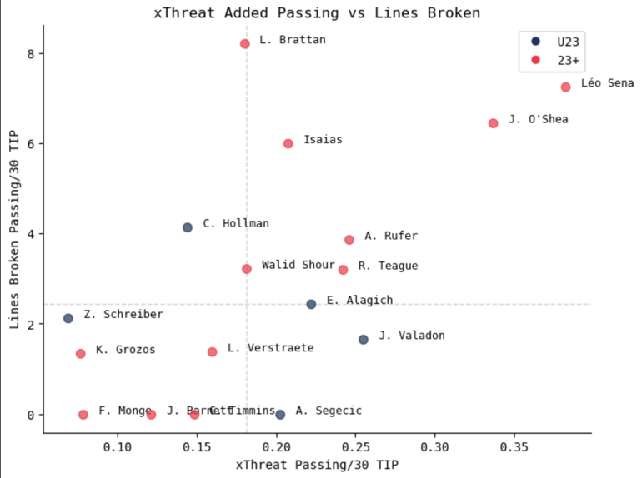
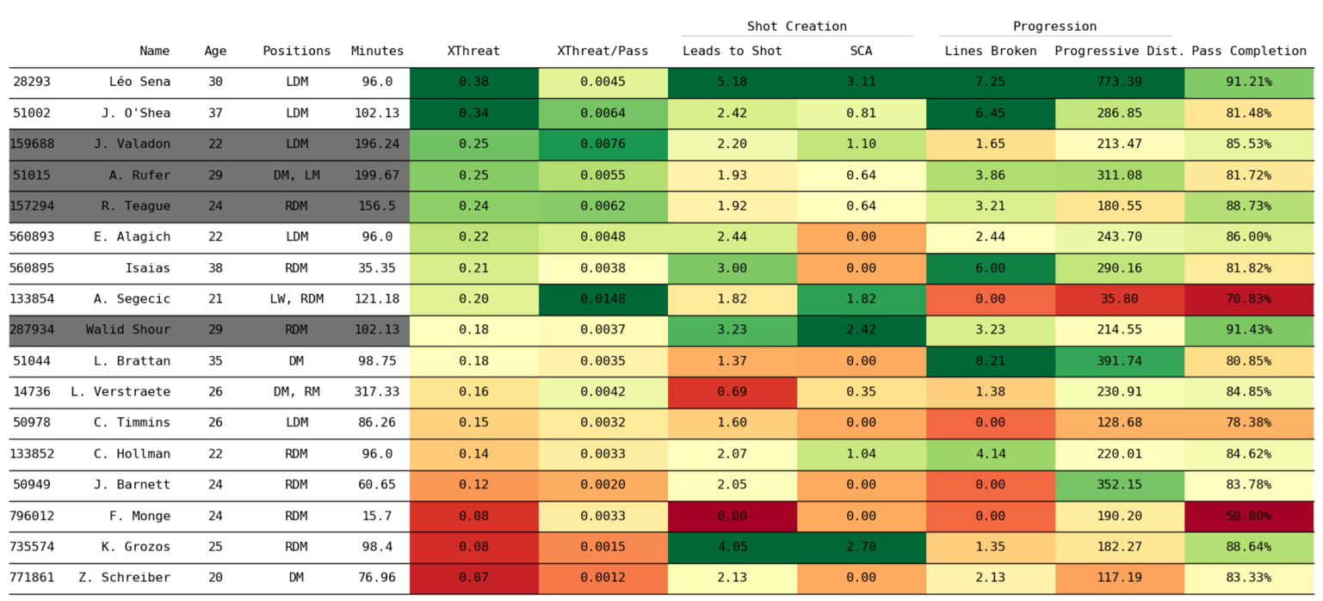
nkrackeler@umass.edu | (518) 226-9119
The below chart includes a few key passing metrics both in shot creation and progression, as well as expected threat. While I created and analyzed aggregators with close to forty metrics in total for this project, for legibility I've narrowed it down to these seven. All stats are expressed in per 30 minutes TIP unless otherwise specified.

In order to scout midfielders with good passing ability, two types of passing are most important: progressive passing and final third creative passing. An initial graph with xThreat passing on the X and lines broken passing on the Y displays players who excel in one or both of these skills. Jay O'Shea and Léo Sena stand out as outliers in both, while Louis Brattan and Isaias are standout progressors. Jordi Valadon is creative but not progressive, while Ryan Teague and Alex Rufer stand out in both categories. Let's dive deeper into various stats to investigate each of these categories further.
Every club would love to sign game breaking talents from the Premier League, like Adam Wharton, but almost none have the budget to shop in that pool. The task becomes, then, finding players within a team's scouting pool that can impact the game in a similar way. Wharton is a box-to-box central midfielder who excels at final third creation, while offering good progressive passing and aggressive defending numbers. Until recently this would have been discoverable using a simple FBref search.
Using SkillCorner's Open Data repository, we can look through the Australian A League to identify a similar player who could be signed by a team who are at a level to recruit in Australia.
Important: this dataset is only ten randomly selected matches from last season's A League, which is not enough of a sample to draw real conclusions. For this exercise, I’m acting as if I have a more significant sample, and all code is written to be repeatable and work with any amount of SkillCorner data with very minimal alterations.

Of the midfielders who created the most expected threat, Jay O'Shea is 37 and largely a set piece contributor, and Léo Sena is 30 and has a heart condition that may prevent him from ever playing again. Ryan Teague, Alex Rufer, Walid Shour, and Jordi Valadon (shown in gray), however, also display enticing numbers. Let's investigate these players further using pass maps
The color scale of these charts is tiered: a pass will be red if it is marked 'dangerous', even if it is also line breaking or forward, then if not it will be marked line breaking, then forward.
Only forward, line breaking, or dangerous passes are included. This means that passes in black that appear to be backward are mislabeled by SkillCorner. I have reported this to the provider and will use X coordinates to determine forward passes in the future.
Looking at these maps, Valadon and Rufer stand out. Valadon's contributions in the final third are the most dangerous, while Rufer is the most active in progressing play in deep and middle build up. Teague offers little in deep buildup but contributes in his half. Walid Shour barely shows up at all, perhaps indicating that his stellar metrics may have been due to volume or high-quality play from teammates.
Singling out Valadon and Rufer, let’s look at each player’s play outside of passing.
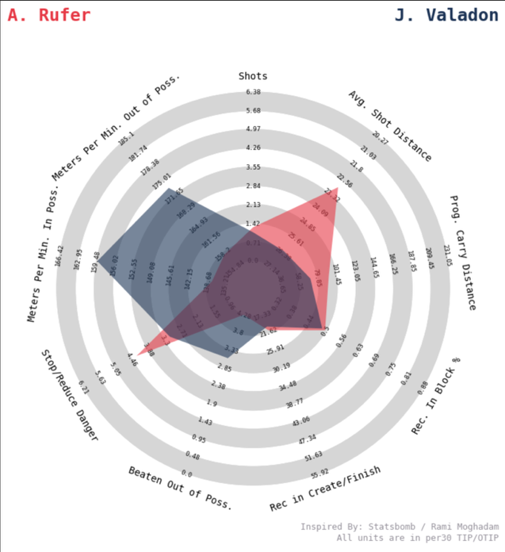
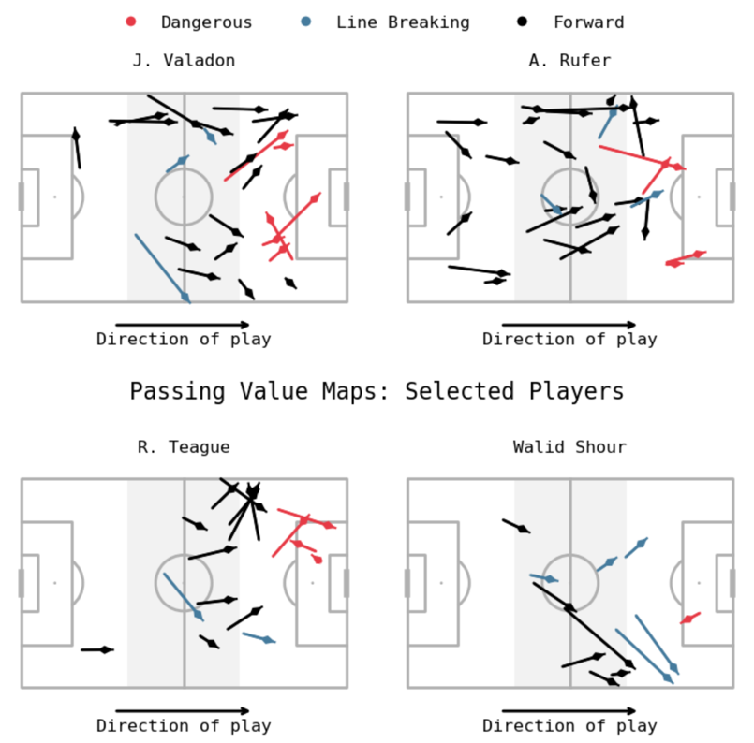
Taking into account pass completion percentages and XThreat/pass from earlier, both players profile more as 8s than 6s in possession. Both are very high in terms of XThreat per pass, indicating incisive passes in forward areas, and Rufer has a very low completion percentage, indicating that he tries difficult passes at a rate that might be too high risk for a 6 playing in front of the defense. This is particularly concerning for Rufer given how many of his valuable passes came in middle and defensive thirds. In this way, they are both much more similar to Adam Wharton than, say, Elliot Anderson.
Given Valadon is still 22 and provides serious value passing in the final third and some aggressive defending upside, he would be my recommendation for a team scouting Australia for a creative midfielder. Rufer might also be an option if his age (29) isn't prohibitive, and if a team is willing to accept his very aggressive defending and passing style.
For my code and more complete breakdowns and reflections, check out my GitHub linked on the front!
This radar chart tells us a few things. Valadon is a very active runner both in and out of possession, covering significant ground. Rufer, while running much less, is able to stop or reduce danger at a high clip but is beaten out of possession the most in the dataset. Valadon is similar but slightly less aggressive. Neither player is a particularly active ballcarrier or shooter, but Valadon shoots from very far out on average which is a negative. Neither player receives the ball particularly often, and both often receive outside the defensive block.
Both players profile defensively as aggressive defenders rather than sitters, meaning they may not be suitable for a team looking for a very passive 6 to screen the defense. Valadon's running may be more useful in transition. Rufer may provide some shooting value, getting shots from decent positions at a reasonable clip (the shots wedge is skewed heavily by an outlier who played a lot of minutes at left wing).

